**Vacant Lot Greening**

Philadelphia has a novel vacant lot greening program that turns a few lucky vacant lots into mini public parks. We mapped out the locations and dates of all vacant lots in Philly - both greened and ungreened.

**Figure 1: Vacant Lots in Philadelphia**

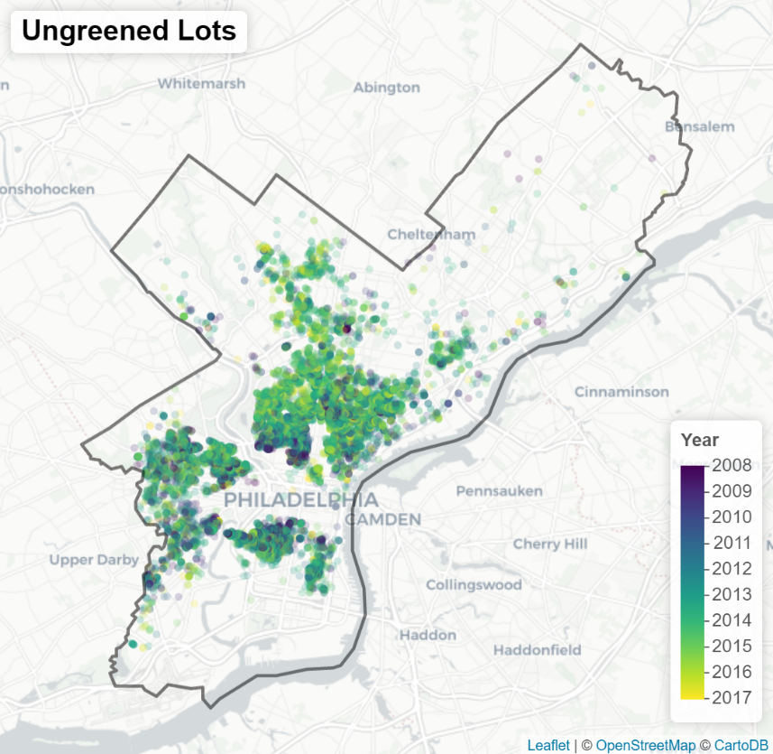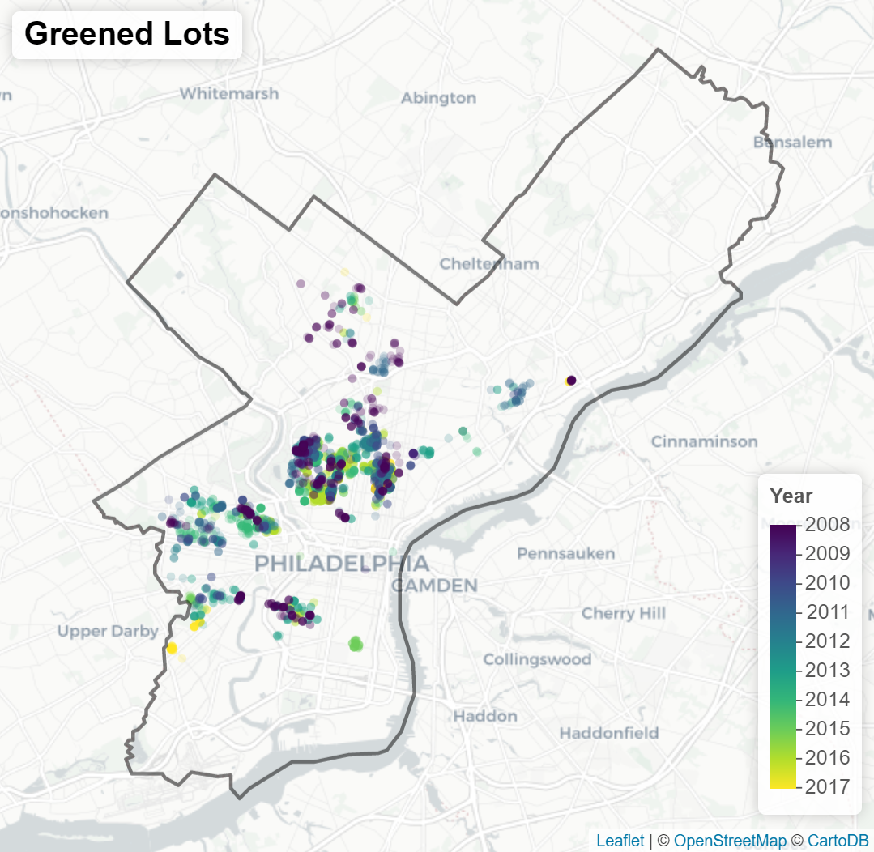

**Source:** Data from Pennsylvania Horticultural Society and Philadelphia Licenses and Inspections Office

**Notes:** Built with leaflet.js